* Servlet component is single instance and multiple threads component.That is multiple requests given to servlet component will work on single object of servlet component.

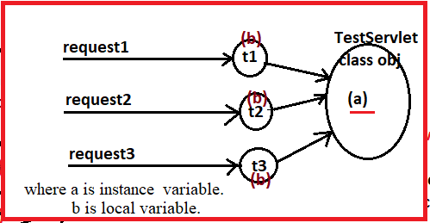

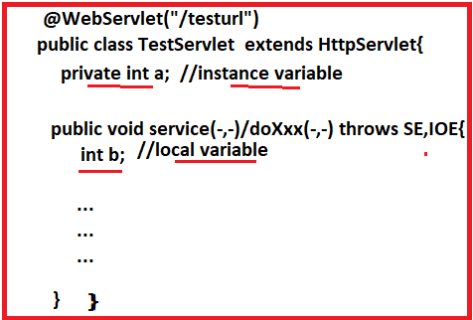

**Problem:-** The instance variable (a) of servlet component is not thread safe by default because multiple threads will act on single copy of instance varible while executing the service(-,-) or doXXX(-,-) method for multiple requests.

**Solution:-**  we can make this variable as thread safe instance variable by either

Declare the synchronized block and access instance variable in that inside the service(-,-) or doXXX(-,-) method or declaring the service(-,-) or doXXX(-,-) methods as synchronized methods.

Local variables placed in service(-,-) and doXXX(-,-) method are by default thread safe variables.Because every thread will gets own copy to local variable.

**Servlet To DB Communication:**

The servlet component communicates DB for

1. To save inputs(Form Data) permanently in DB.

EX:-Customer Registration Form Data.

Employee Registration Form Data.

1. To save Generated Results permanently in DB.
2. To Get the Data from DB.

**Different Approaches to place JDBC Code in Servlet Component:**

**i.Approach:1**

* Create Connection object in init(-) method.
* Use the Connection object in service(-,-) and doXXX(-,-) methods.
* Place closing statement in destroy(-) method.

**Disadvantages:-**

1. The Connection object should be taken as instance variable. So it is not thread safe. It leads to “Data Inconsistency problem”.

EX:-

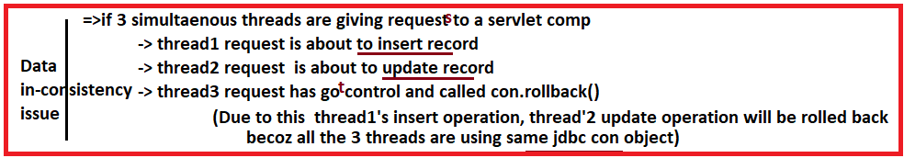

1. Taking the synchronized service(-,-) and synchronized doxxx(-,-) method allow only request at a time on servlet component. By this web application performance will reduce.

**ii.Approach:2**

* Create connection object in Service(-,-) or doXXX(-,-) method.
* Use connection object for developing persistence logic in same method.
* Place connection closing statement in Service(-,-) or doXXX(-,-) method.

**Advantage:-**

1. The Connection object reference is stored in local variable of service(-,-) method. So It is thread safe by default.

**DisAdvantage:-**

Multiple requests given to servlet component uses multiple JDBC connection objects. More connections to DB s/w will be opened.

**iii.Approach:3**

* Get connection object from “connection pool” in service(-,-) or doxxx(-,-) method.
* Use connection object for developing persistence logic in same method.
* Return the connection object to “Connection pool” in service(-,-) or doxxx(-,-) method.

**DisAdvantage:-**

We must choose WebServer/Application Server that should supports JDBC connection pool.

**GUIDELINES:-**

* If web application is small scale web application , then choose “Approach-2”.
* If web application is small scale or large web application, then choose “Approach-3”.

Example:- This application demonstrates Servlet to DB communication using second approach.

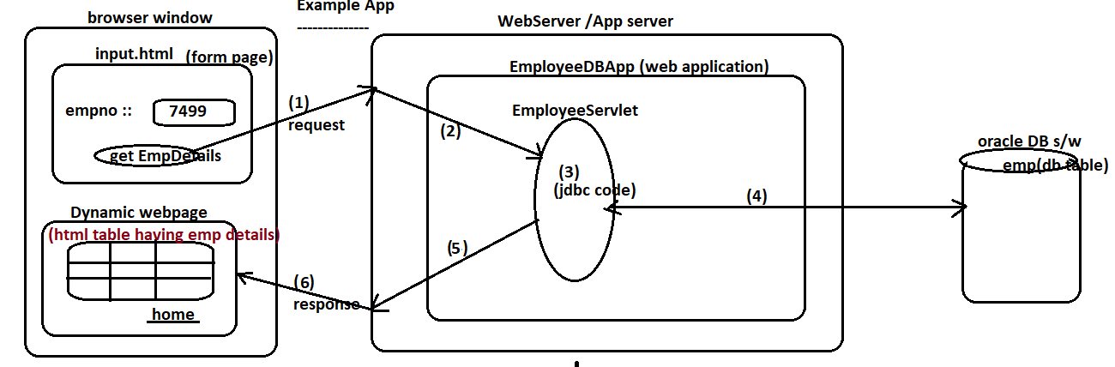

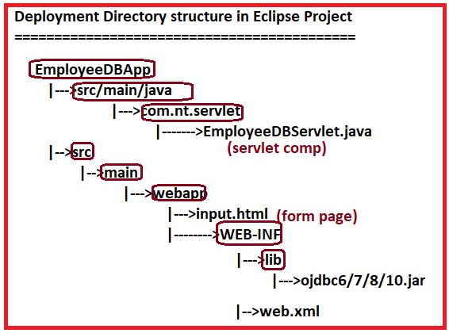

Note:- In web application we need to load the JDBC Driver class explicitly.

**Step:1**

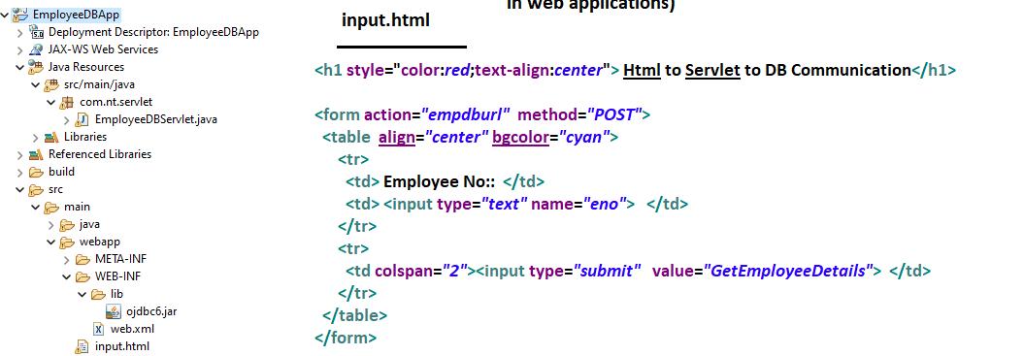

**Step:2**

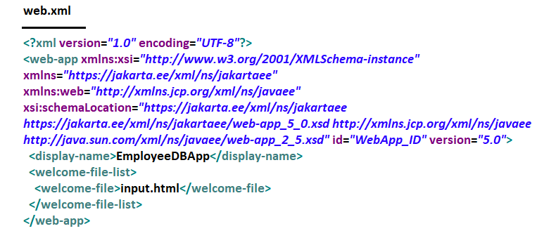

**Step:3**

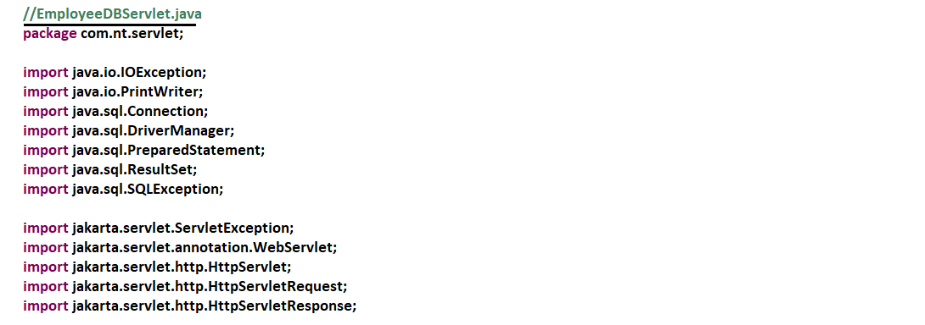

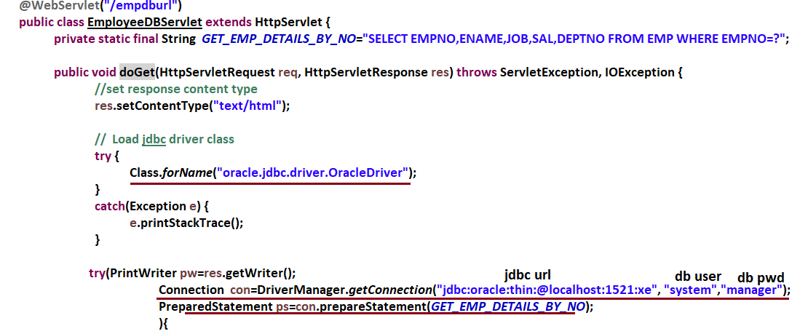

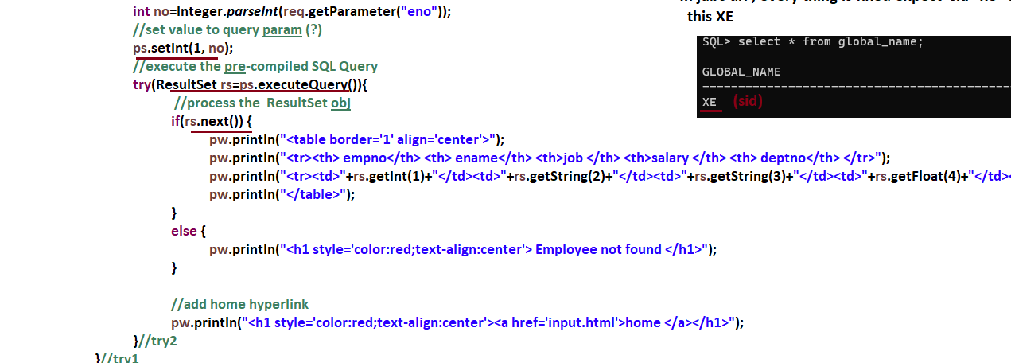

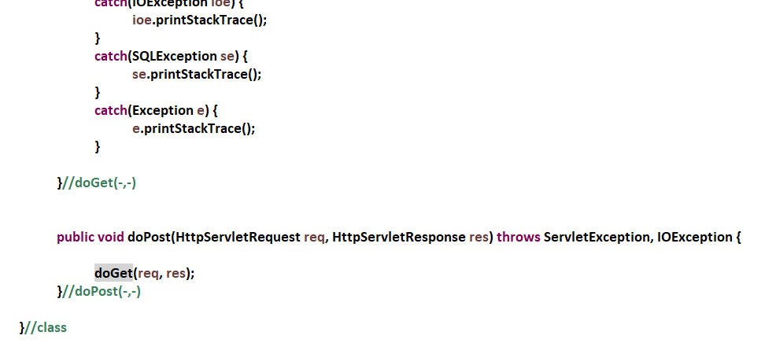

**STEP:4**

